Explore the factors that may be associated with obesity

Xueyan Hu

2024-05-03

# 1. Summary/Abstract

Obesity is a chronic complex disease which may increase the risk of severe health issues including diabetes, cardiovascular disease and even cancers. And the condition of obesity in real life could be connected to individual physical behaviors, such as physical activity frequency, alcohol consumption, age, gender and inherit. The project is to explore the potential factors that might be related to obesity level using machine learning models to a dataset collected from an investigation done in South American countries including Colombia, Peru and Mexico. The data analysis result has shown that age, gender, family history, drinking water, physical activity, and commute transportation are all predictors for obesity level, which is represented by individual BMI. As for the outcome, when linear model is fit to data which has BMI as continuous variable, the performance is better than using obesity level as categorical variable.

# 2. Introduction

## 2.1 General Background Information

[Obesity](https://www.who.int/news-room/fact-sheets/detail/obesity-and-overweight) is a chronic complex disease defined by excessive fat deposits that can impair health. Overweight and obesity are predominately a result of a sustained positive energy balance, stemming from a combination of excess dietary energy intake (mainly due to poor eating habits) and reduced energy expenditure (due to lack of physical activity and prolonged sedentary activities). It is a significant risk factor for and contributor to increased morbidity and mortality, mainly by its increasing risk of type 2 diabetes and heart disease, as well as certain types of cancer and chronic diseases, including osteoarthritis, liver and kidney disease, sleep apnea, and depression (Pi-Sunyer, 2009). Also it does affect bone health and reproduction.

In the recent decades, obesity has become a more and more common and severe problem across the world with worldwide obesity rates tripling since 1975, thus reaching pandemic proportions (Moschonis & Trakman, 2023). Worldwide adult obesity has more than doubled since 1990, and adolescent obesity has quadrupled. In 2022, 1 in 8 people in the world were living with obesity. In the US. the situation seems similar with the worldwide trend. In 2022, 22 states had at least 35% of adults with obesity, up from 19 states in 2021. Ten years ago, according to [CNN Health](https://www.cnn.com/2023/09/21/health/obesity-more-common-states-cdc-data/index.html), CDC said there was no state had an adult obesity prevalence at or above 35%.

Obesity level is basically defined by Body Mass Index ([BMI](https://www.cdc.gov/obesity/basics/adult-defining.html)). BMI is a person’s weight in kilograms divided by the square of height in meters. A high BMI can indicate high body fatness. BMI less than 18.5 is defined as underweight; BMI range between 18.5-24.9 falls within the healthy weight range. If BMI is from 25 to 29.9, then the person is regarded as overweight. And when someone’s BMI is higher than 30, he/she is at the obesity range.

There is no doubt that obesity is a multifarious disease due to cryogenics environments, psycho-social factors and genetic variants in most cases, but many factors can contribute to excess weight gain including eating patterns, physical activity levels, and sleep routines. Social determinants of health, genetics, and taking certain medications also play a role. There is an [article](https://www.nichd.nih.gov/health/topics/obesity/conditioninfo/cause) by NIH listing some causative factors for obesity, including food and activity, environment effect, genetics, health conditions and medications, stress, emotional factors, and poor sleep. Other [articles](https://ro.co/weight-loss/obesity-causes-risk-factors-strategies/#risk-factors-for-obesity) also have mentioned hormone as cause and family history, age, sedentary lifestyle and smoking as risk factors for obesity. But alcohol consumption is not that frequently mentioned as far as I know.

There is a lot of discussion on the Internet and social media about fitness and weight loss, and people assume that physical activity can lose weight as a fact. Also KOLs (Key Opinion Leader) usually encourage people to drink more water for higher metabolic levels. Although I haven’t seen any actual data for proving it, some papers have pointed the effect of drinking a lot of water on body weight (VINU & ANJALI, 2013). At the same time, the effect of physical activity to lose weight is also different from person to person.

In addition, according to what I learned from nutrition course, alcohol consumption may be related to weight gain because alcohol metabolism and carbohydrate metabolism both go through the same pathway/cycle in the middle and late stages (Cederbaum, 2012). Ethanol is converted into acetaldehyde by the action of ethanol dehydrogenase, and the acetic acid produced by acetaldehyde dehydrogenase eventually enters the tricarboxylic acid cycle to produce energy, which is consistent with process of the consumption of carbohydrates for energy. If someone is lacking of oxidative enzymes, ethanol is nonoxidatively metabolized by two pathways. A reaction catalyzed by the enzyme fatty acid ethyl ester (FAEE) synthase leads to the formation of molecules known as FAEEs. A reaction with the enzyme phospholipase D (PLD) results in the formation of a phospholipid known as phosphatidyl ethanol (Zakhari, 2006). No matter how calalystic reactions work, finally alcohol will be converted to the reagents for tricarboxylic acid cycle and then energy is released.

## 2.2 Description of data and data source

The data is obtained from a website [UCI Machine Learning Repository](https://archive.ics.uci.edu/dataset/544/estimation+of+obesity+levels+based+on+eating+habits+and+physical+condition) together with a paper as a source, which have collected the survey results of individuals from the countries of Mexico, Peru and Colombia on their eating habits and physical condition, as well as their estimation of obesity levels. The original dataset contains 17 variables and 2111 observations, labeled with the class variable Obesity Level which has 7 categories (Palechor & Hoz Manotas, 2019). The variables include gender, age, height, weight, family history, eating habits (high caloric food, vegetables, main meals, snacks), smoking, alcohol consumption, water consumption, physical activity, technological devices usage, commute transportation, and their obesity level according to the BMI of each observation but BMI value is not in the dataset directly. Over weight level 1 refers to people whose BMI is in the range of 25-27.5, while weight level 2 is 27.5-30. But these 2 levels couldn’t be found on CDC website. Obesity is frequently subdivided into categories: Class 1: BMI of 30 to < 3; Class 2: BMI of 35 to < 40; Class 3: BMI of 40 or higher.

## 2.3 Questions/Hypotheses to be addressed

Several questions will be explored during the following analysis.

1. If higher frequency of physical activity and drinking more water could keep people away from obesity.
2. Whether there is a relationship between alcohol consumption frequency and obesity level.
3. What variables/risk factors could be good predictors for obesity level, and what machine learning model could be fit and make good predictions for new given data.

# 3. Methods

Data cleaning including generating necessary variable, renaming categories and variables and so on.

First to take a deeper look of the data, I would like to do some descriptive analysis including bar chart, boxplot, scatterplot etc. to indicate the distribution of the data.

Then simple linear model will be applied to explore the relationship between variables and outcomes (both categorical and numeric), and proper predictors will be pick out from the variables. And then machine learning models will be chosen and fitted to the dataset and each performance metric will be determined and compared for reporting the “best” model among the choices based on reality.

## 3.1 Schematic of workflow

## 3.2 Data acquisition

The dataset presents the results of a survey on the topic of obesity including eating habits and personal physical conditions and answers to behavioral questions. The paper have pointed out that 23% of data are collected by themselves directly from users through a web platform while 77% of the data is synthesized using the Weka tool and the SMOTE filter.

## 3.3 Data import and cleaning

The detailed raw data and processed data are stored in ‘data’ folder. And the code for data cleaning is in the ‘processing-code’ subfolder under ‘R’ folder.

I made a code book based on the article reporting this dataset (Palechor & Hoz Manotas, 2019) first before doing any cleaning.

There is no missing value in this dataset.

Obesity level is a categorical variable defined by BMI range, so BMI as a new variable is created and it could be analyzed as a numeric variable. Also, to make the variable name easy to understand, I changed some abbreviated names to ones with fully spelled key words. Male is replaced by 1 and female by 2 under Gender variable for more convenient further analysis.

## 3.4 Statistical analysis

Bar chart, box plot will show the distribution of obesity level by different variables, as well as the population features of the people under investigation. All figures will be saved in ‘figure’ subfolder under ‘result’ folder and shown in the manuscript.

By fitting the data with simple linear model, the result will show whether each independent variable has main effect to the dependent variable and the possible interactions between variables will also be detected. And the summary table is stored in ‘table’ subfolder under ‘result’ folder.

# 4. Results

## 4.1 Exploratory/Descriptive analysis

Bar chart shows that the ratio of male and female populaiton is quite close to 1:1, which means genders of the cohort under investigation are balanced.

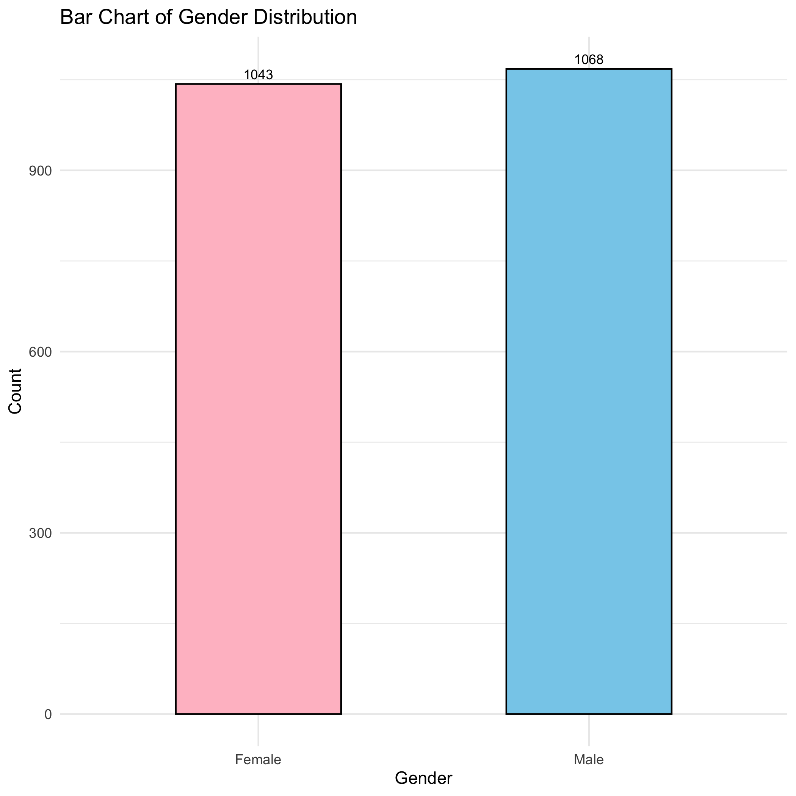

Figure 1. Gender distribution.

The age distribution figure shows that people aged 20 to 30 account for the largest proportion of the total population which is nearly two thirds of the total population. Then the second highest ranking is 30-40, occupying about a quarter of the total population.

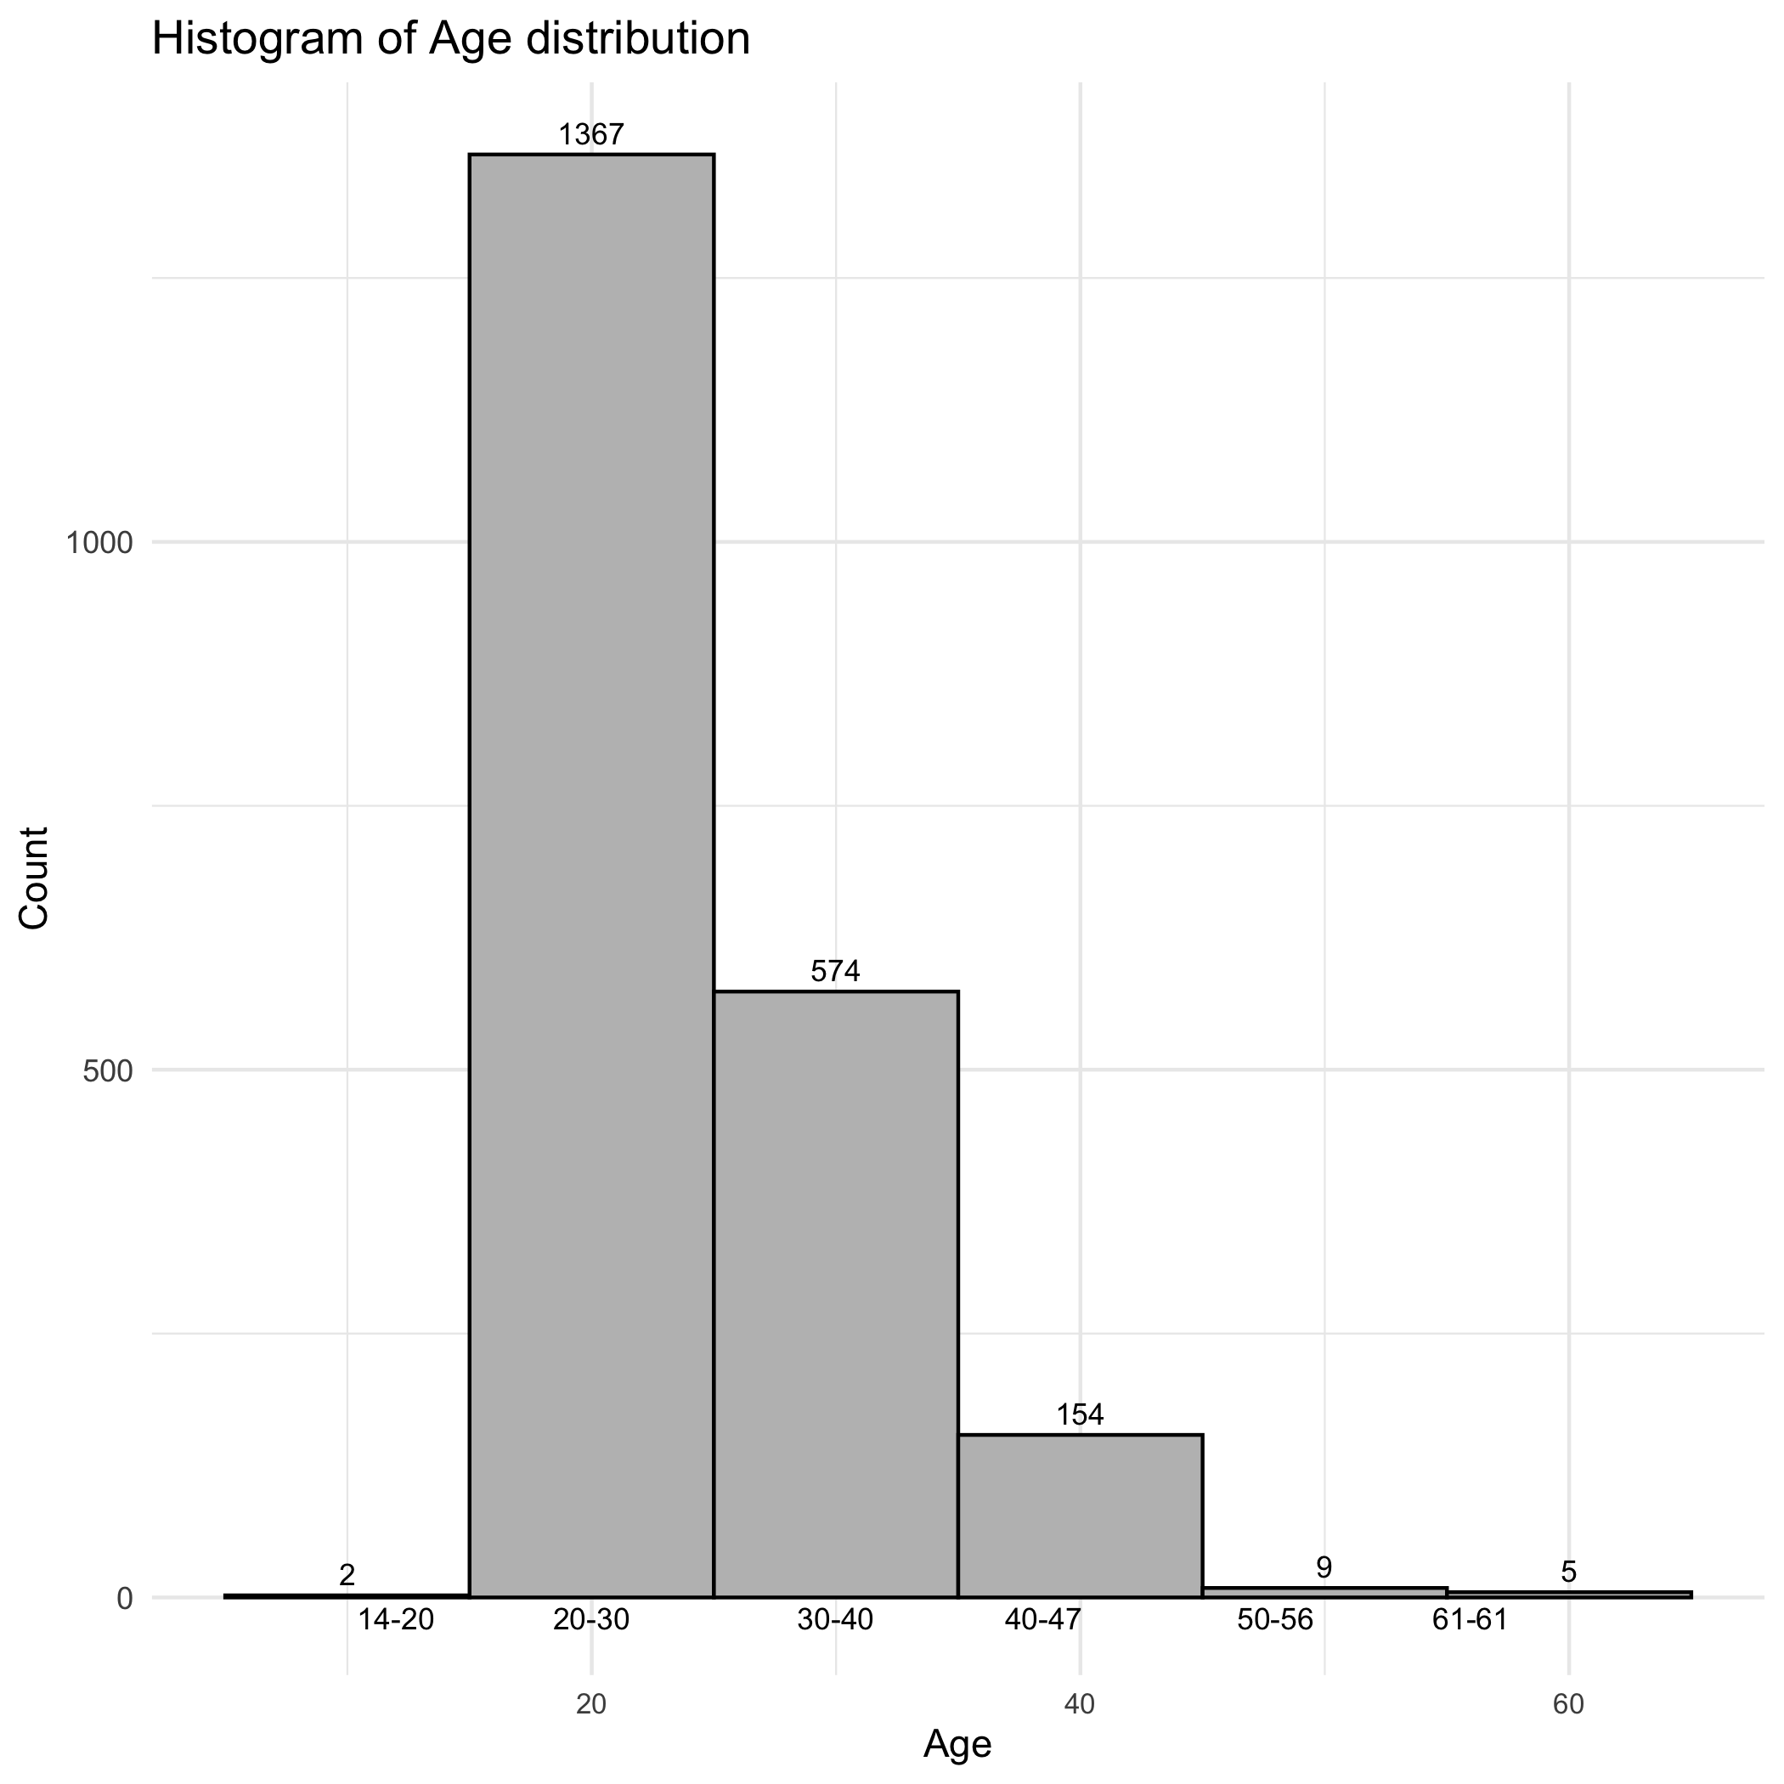

Figure 2. Age distribution

It can be seen that almost three fourths of the people are identified with over weight. The highest population fall into over weight level 1, while the under weight level has the lowest population.

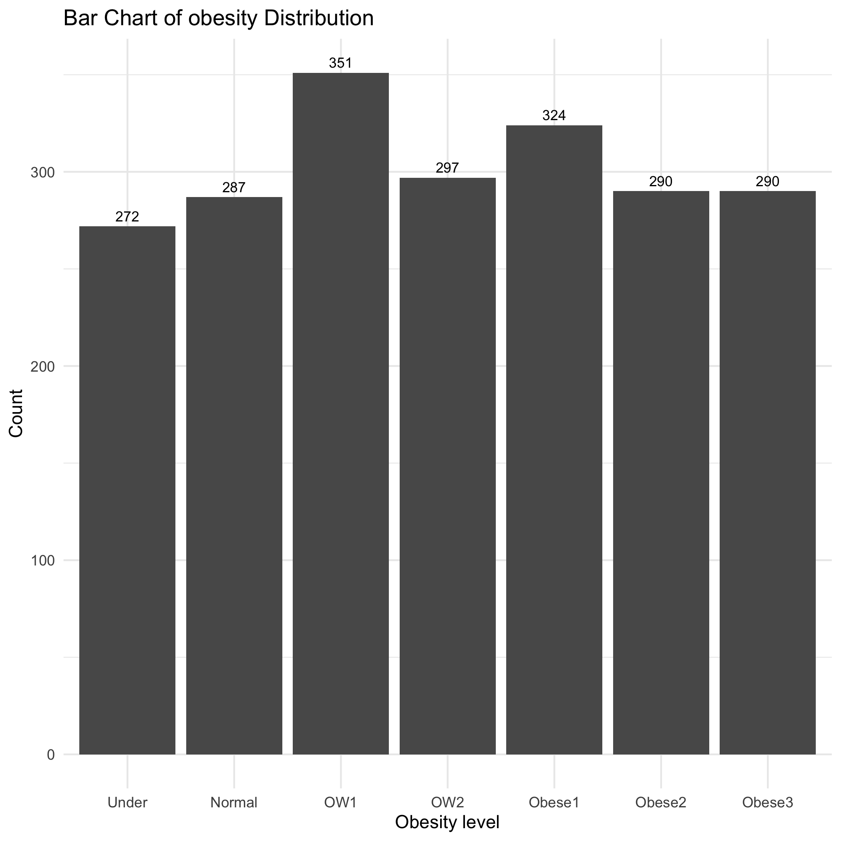

Figure 3. Obesity level distribution.

The gender ratio is close to 1:1 but its distribution under each obesity level is different. There is no obvious pattern of obesity levels by gender. The ratios of male and female in other obesity levels are close to 1:1 except for overweight level 2 that women occupy almost all of the population and Obese level 1, most of people under which are male. In addition, around two thirds of underweight people are men.

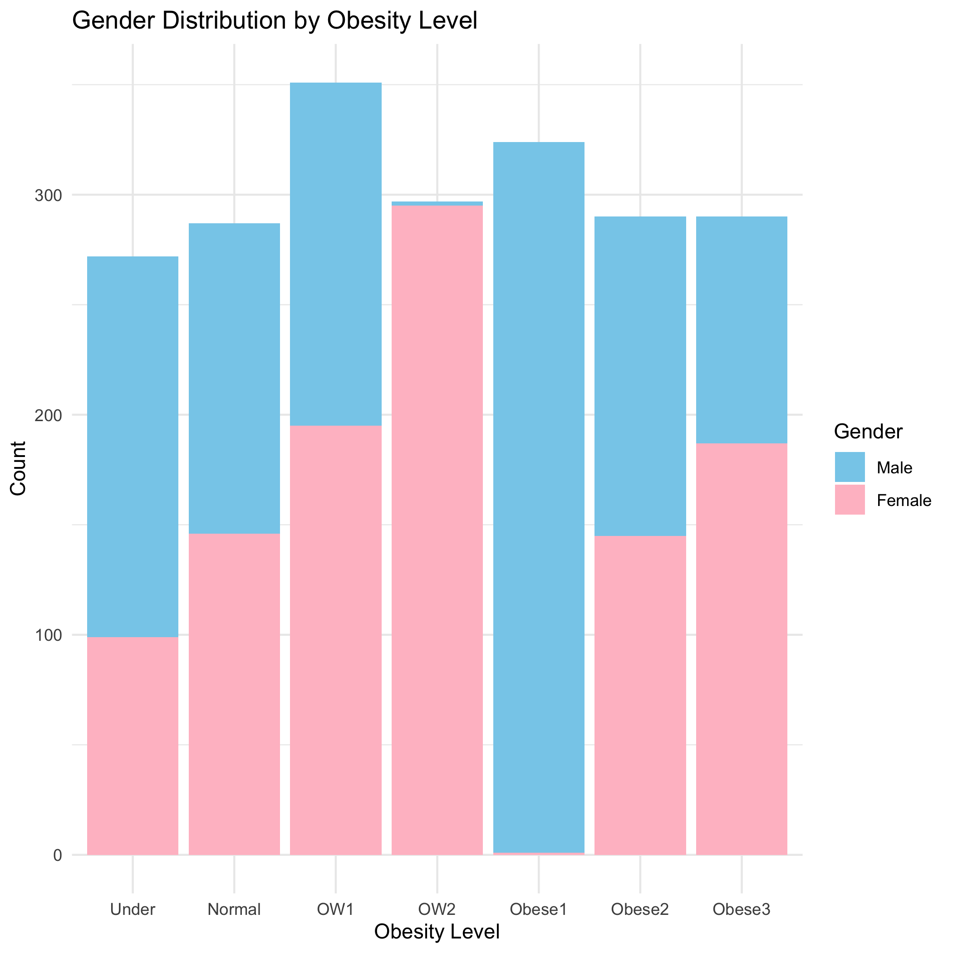

Figure 4. Gender distribution in each obesity levels.

Since people aged between 21 and 30 occupy the largest part of the total population, I could expect that in each level, most of people would fall in the age group of 21-30. And it can be seen from this bar chart. Moreover, more than half of underweight people are from the age group 0-20, it might reflect the problem that health condition and nutrition intake should be regarded seriously by the countries that attend the survey.

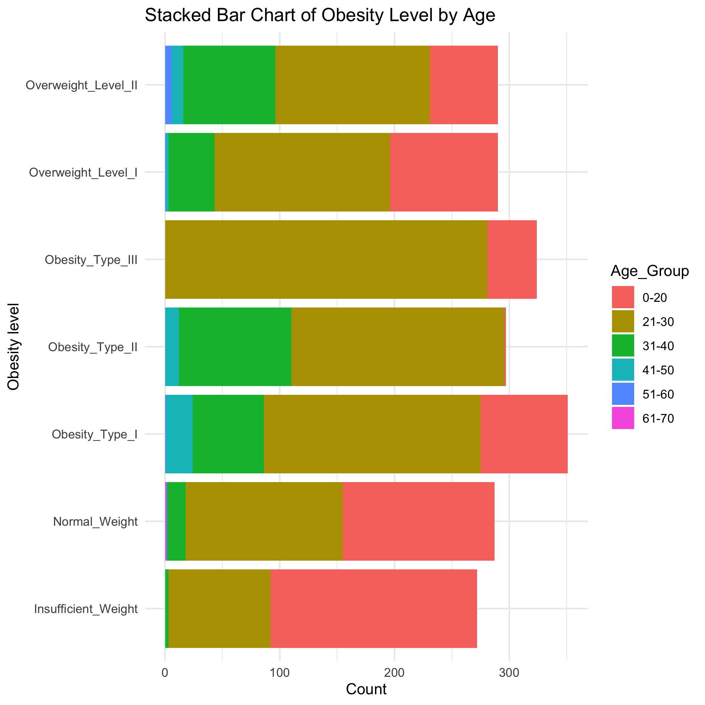

Figure 5. Age distribution in each obesity levels.

It is apparent that people with family obesity history may tend to be overweight according to figure 6 below. The median BMI is much higher for people who have family obesity history than the people who don’t. And the data density of no family history group is aggregated at the level under 30. There is an article talking about family obesity history and its impact on children in the family. The article finds childhood obesity is positively correlated to the obesity status of their parents (Moschonis & Trakman, 2023). When both parents were obese, approximately half of the children in Europe were overweight. This highlights the presence of an “obesogenic environment” typically fostered by obese parents, impacting not only themselves but also their children. This environment often involves reduced physical activity, increased sedentary behavior such as screen time, and higher intake of calorie-dense foods, contributing to weight gain across the family. Therefore, family history is not only a genetic effect, lifestyle, environment also plays an important role for offspring obesity.

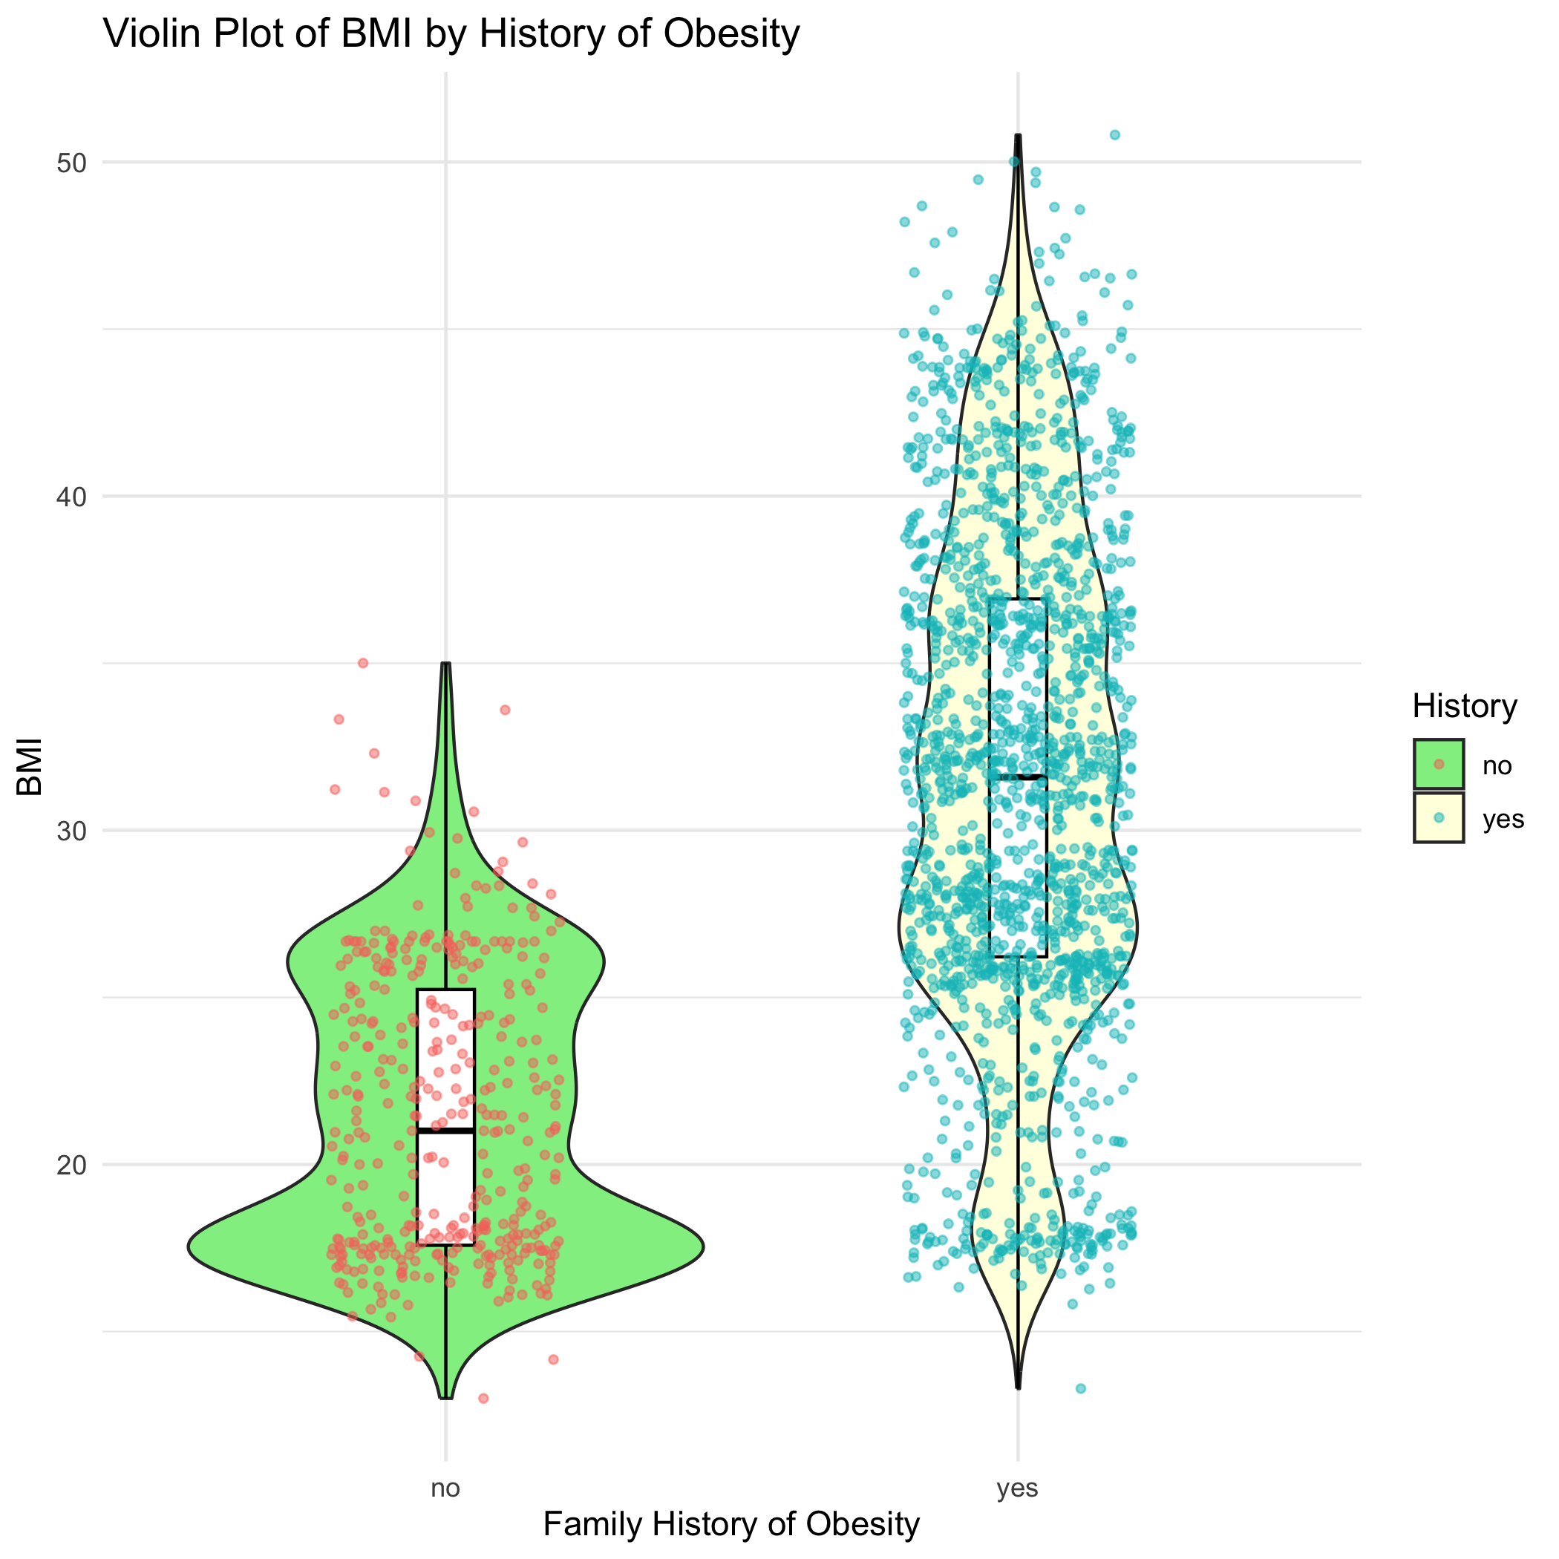

Figure 6. Violin plot of BMI by family obesity history.

## 4.2 Basic statistical analysis

Since some obvious relationship could be shown in figures, I choose other variables as predictors in exploratory analysis.

First, for exploring the correlation between transportation type and physical activity frequency, transportation types were converted into numbers indicating the energy consuming levels from 1 (lowest automobile) to 4 (highest walking). Then correlation function was used to calculate the coefficient for these two variable but it was pretty low (0.0059).

Then, linear model for BMI is fit by both water consumption and physical activity. And the result indicates that there is a connection effect between them two, which means that both of them contribution to obesity control.

Also, single indicator, alcohol consumption is used and BMI as an outcome to fit linear model. It shows that if an individual consumes alcohol sometimes than never, his BMI increase 3.98. But the correlations are all negative for level 3 and 4, which means consuming more alcohol may decrease BMI.

Although age distribution is not so balanced in the dataset, the linear model of obesity by gender and age is still tired to explored. So simple linear model is fit to the dataset using gender and age as independent variables. The result indicates the interactions between them. It is a factor out of my expectation. And this interaction is considered to be included for next machine learning models.

In the last model selected is all the variables that I think may have effect on BMI as predictors and BMI as outcome.

Since it is quite obvious that family history is an important factor for obesity, and also some reasons how family obesity could influence the kids involved have been mentioned above in the introduction part, it is skipped for this basic exploratory analysis here, but will be included in the following part.

## 4.3 Full analysis

Table 1. Summary of each machine learning model applied to the data and its metric value comparison.

| Model | Predictor | Metric Value | Metric Value on testing data |
| --- | --- | --- | --- |
| Linear null | - | RMSE=8.01 | RMSE=7.99 |
| Linear regression 1 | Gender, Age, History, Water, Alcohol, FAF, MTRANS | RMSE=6.42 | RMSE=6.54 |
| Linear regression 2 | All | RMSE=6.29 | RMSE=3.81 |
| LASSO model | All | RMSE=6.34  l=0.023 | RMSE=6.47 |
| Random forest | All | RMSE=3.35 | RMSE=3.97 |
| Logistic null | - | Accuracy=0.17 | Accuracy=0.15 |
| Discriminant analysis | Gender, Age, History, Water, Alcohol, FAF, MTRANS, Gender_Age | Accuracy=0.50 | Accuracy=0.50 |
| Multinominal logistic regression | All | Accuracy=0.55 | Accuracy=0.50 |

The above table has listed all of the the models have been chosen to fit the data together with the null models.

When BMI is used as a continuous outcome, linear regression models can be applied to the data. Compared to the linear null model, all of the ML models perform better according to RMSE value. Since it is reasonable that physical activity is a potential factor that may influence the obesity level, although linear model with all variables and interactions has higher RMSE, regression model 2 that picks all of the predictors is better. Then since random forest model selects all predictors and RMSE value is relatively lower among all the linear models, RF model is the choice for linear model.

The figure below shows the prediction condition using random forest model together with the null model on testing data. Both sides of the 45 degree line have outliners and the scatters are not clustered close enough to this line which indicates the prediction is not really well.

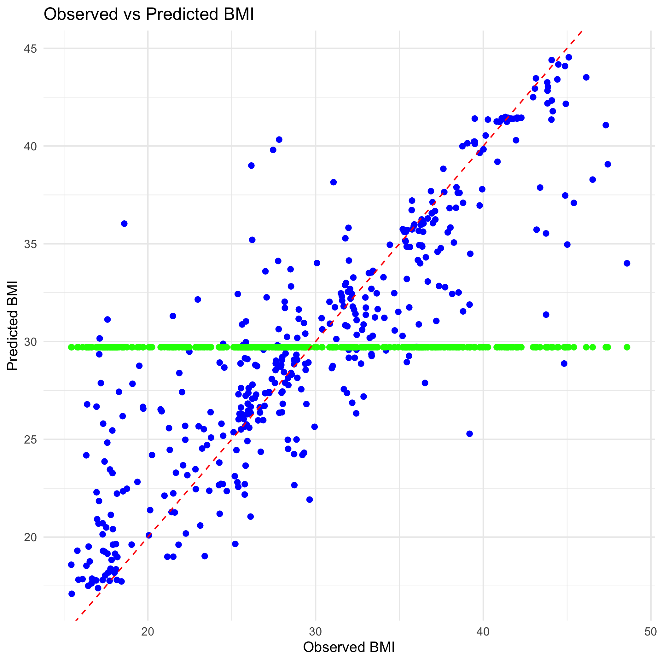

As for obesity level as a categorical outcome, logistic models are fit to the data. And accuracy is used as the performance metric for this evaluation. First, both the models have better performance than null model. And according to the accuracy, multinominal logistic regression performs better.

Because random forest model is chosen between linear regression models and multinominal logistic regression between logistic models, test data is used to assess the quality of these two models separately. And the new RMSE on test data for random forest model is 3.97, and it is 3.35 when the model is trained and cross validation is applied. And the new accuracy is 0.50 when it is used on test data which is the same as it is trained. The metric value difference is a sign that both of the models are overfitting.

So all of the models are assessed by making predictions test data in the table above and new metric values are collected again. For linear regression 1, the RMSE on testing data is 6.54, which is much higher than that on training data. So this model is not doing prediction well. The new RMSE for linear regression 2 is 3.81 lower than 6.29 on training data, which is a sign of good prediction. Besides, the new RMSE of LASSO model is 6.47 which is slightly higher than training. Discriminant analysis has the same accuracy for both training and testing data. Based on all the result of the machine learning I have used on dataset, I think linear regression model with LASSO regularization is a good choice among them. Also, discriminant analysis has good performance on predicting in testing data.

# 5. Discussion

## 5.1 Summary and Interpretation

I chose a dataset that summarize an investigation result done in South American countries about individual physical behaviors and the classification of obesity level based on the information of height and weight obtained from the investigation. I had some questions to explore and did data analysis on this dataset. Samples were collected randomly, and some of the data was synthetic. The result of data analysis indicate that both environmental factors and personal lifestyle habits can affect the degree of obesity according to bmi as a measurement. It could provide some suggestions from this project that, although BMI might change with aging regard to gender, if someone can do more physical exercise, drink more water and consume less alcohol, it will reduce the risk for getting obesity. And relevant departments and organizations can also provide corresponding recommendations and appropriate publicity to increase the awareness of obesity risk factors among residents of these countries and help them develop a healthy lifestyle.

A former study did research on a similar topic with this project, and the analysis indicated that among men, the proportional odds of obesity increase with urban residency, aging, marital status different from single and decrease with current smoking. Among women, the proportional odds increase with urban residency, primary educational level, high total blood cholesterol level and high fasting blood glucose level, and decrease with current smoking (Kaboré et al., 2020). It proved gender, age are risk or caustic factors for overweight or obesity, as well as other environmental factors and body conditions.

I found simple linear model fitting can answer my questions, which were that alcohol consumption was correlated to obesity, as well as there were interactions between physical activity frequency and water drinking amount. In addition, I found there was nearly no correlation between transportation choice and physical activity, which could answer another question I had. At the same time, outside the scope of the problem, I also discovered the interaction between gender and age in this process.

For machine learning model fitting, I found the best predictors for BMI index based on the value of some performance metrics after trying both linear regression and classification models, which were gender, age, family history, water drinking amount, frequency of physical activity, alcohol consumption frequency and commute transportation, and all of the categories were used in the analysis. Although the machine learning models that I used for fitting the dataset are different types and their metrics and not be compared directly, the assessment of model quality using testing data could give a clue for the model selection. Considering all the results of performance metrics, I finally chose liner regression model with LASSO regularization with all predictors plus BMI as the outcome. The reason was that RMSE calculated of predicted MBI values on testing data split from cleaned dataset was as same as the result when it was trained. Also, regularization was applied by LASSO model to reduce overfitting at the same time.

For more detailed information of LASSO model, I took the review advice and tried to extract strongest and weakest coefficient, but the result showed that intercept was both strongest and weakest coefficient. I didn’t figure out how it could be interpret so it is not included in this part.

## 5.2 Strengths and Limitations

BMI is a fast, low cost and easy-to-operate measurement for obesity rated in a population. It applies to most of the people and could fit large population groups better than measuring body fat content. I think my analysis has include two different types of model according to the type of outcome and each type include 2 models, which can provide more information and the result can be shown in different aspects as well as more choices were provided. Also, interactions between predictors were found and included in the model fitting process. Both predictors with and without interactions were all fit and compared with each other. And LASSO model was used for decreasing overfitting.

First, there is a problem with my outcome, BMI, which [could be misleading when being used as an indicator for obesity](https://www.yalemedicine.org/news/why-you-shouldnt-rely-on-bmi-alone), because BMI value could be misleading because a person with lots of muscle and minimal body fat can have the same BMI as a person with obesity who has much less muscle. The other reason is that BMI was invented based on European white men and didn’t take into account that a person’s body fat also tends to vary depending on their sex, race, and ethnicity. So it will be better to take fat content into consideration when doing analysis for obesity. But it is not included. The difficulty for obtaining fat content might be that it consumes time to measure with specific machine. Doing tuning for random forest model has been tried but I failed for running it successfully, so this could be a limitation. And maybe there could be more metrics that I can also calculate but I only chose 1 for each model. Furthermore, chatGPT said that even if testing result has a sign for well predicting, there still could be other factors for further assessment such as F1-score and so on. But base on my understanding, I don’t know what other methods I could choose from so I just stopped here.

## 5.3 Conclusions

The take-home message for this project is that obesity is correlated to individual physical behaviors. Based on the result of data analysis, age, gender, family history, drinking water, physical activity, and commute transportation are all predictors for obesity level which is represented by BMI index.

# 6. References

Cederbaum, A. (2012). ALCOHOL METABOLISM. *NIH Public Access*, *16*(4), 667685. <https://doi.org/10.1016/j.cld.2012.08.002>

Kaboré, S., Millogo, T., Soubeiga, J. K., Lanou, H., Bicaba, B., & Kouanda, S. (2020). Prevalence and risk factors for overweight and obesity: A cross-sectional countrywide study in burkina faso. *BMJ Open*, *2020*(10), e032953. <https://doi.org/10.1136/bmjopen-2019-032953>

Moschonis, G., & Trakman, G. L. (2023). Overweight and obesity: The interplay of eating habits and physical activity. *Nutrients*, *15*(13). <https://doi.org/10.3390/nu15132896>

Palechor, F. M., & Hoz Manotas, A. de la. (2019). Dataset for estimation of obesity levels based on eating habits and physical condition in individuals from colombia, peru and mexico. *Data in Brief*, *25*, 104344. https://doi.org/<https://doi.org/10.1016/j.dib.2019.104344>

Pi-Sunyer, X. (2009). The Medical Risks of Obesity. *Postgraduate Medicine*, *121*(6), 21–33. <https://doi.org/10.3810/pgm.2009.11.2074>

VINU, V., & ANJALI, J. (2013). *Effect of ‘water induced thermogenesis’ on body weight, body mass index and body composition of overweight subjects*. *7*(9), 1894–1896. <https://doi.org/10.7860/JCDR/2013/5862.3344>

Zakhari, S. (2006). Overview: How is alcohol metabolized by the body? *Pubmed Central*, *29*(4), 245–255. <https://doi.org/PMCID: PMC6527027>